Multiple-choice section – choose the correct answer

Question 1 [9.1]

A jar is filled with 2500 jelly beans. A random sample of 20 is taken from the jar and it is found to contain 3 black, 9 green, 2 red and the rest orange. Of the 2500 jelly beans in the jar, the expected number of black jelly beans and orange jelly beans, respectively, would be:

A 400, 800 B 600, 1200 C 375, 750 D 300, 600

Question 2 [9.1]

500 penguins were tagged and released into the population. Of a sample of 150 penguins that were caught later, 20 were found to have tags. The estimated population size is:

A 5000 B 2500 C 3750 D 67

Question 3 [9.2]

The mode is:

A the score that occurs the most

B the average set of scores

C the difference between the highest score and the lowest score

D the middle score of a set of scores

Question 4 [9.5]

The list of all possible outcomes is called:

A an outcome B the sample space C the complement D the probability

Question 5 [9.6]

A card is drawn from a standard pack of 52 playing cards. What is the probability it is a diamond?

A  B  C  D 

Question 6 [9.7]

In a Venn diagram, the notation used to represent the complement of *A* is:

A *A* B *A*′ C ξ D *B*

Question 7 [9.2]

Twenty cards, each with a different number from 1 to 20 written on it, are placed in a hat. One number is drawn. What is the probability it is a number divisible by 3?

A  B  C  D 

Question 8 [9.4]

The class centre for a class interval of 20–24 is:

A 44 B 4 C 22 D 21

Multiple-choice results: ___ /8

Short answer section

Question 9 2 marks [9.7]

Choose the correct word from the following list to fill each of the gaps in the following sentences.

*probability Venn diagram outcome union intersection set*

(a) A ____________________ can be used to work out the probability of an event occurring.

(b) The ____________________ of *A* and *B* includes the outcomes that are in *A* or *B* (or both).

Question 10 2 marks [9.1]

Using an example, explain the term ‘population’.

Question 11 2 marks [9.1]

Choose the example from the list below that is both a ‘judgemental’ and a ‘convenience’ sample. Explain your choice.

1 Surveying by email all Mazda drivers on the standard of service at the Mazda dealership.

2 Asking the students who are in the library at lunch time whether or not the sports uniform needs to be changed.

3 Asking a group of nurses in the emergency ward of a hospital their opinion on the need to wear seatbelts.

For your chosen example, is there a likelihood of bias? Explain your answer.

Question 12 3 marks [9.6]

The table shows the number of children in a family and the probability of a family having that number of children.

(a) Complete the table by filling in the missing probability for having 3 children in the family.

|  |  |
| --- | --- |
| Children in the family | Probability |
| 0 | 0.12 |
| 1 | 0.26 |
| 2 | 0.31 |
| 3 |  |
| 4 | 0.08 |
| 5 | 0.04 |
| > 5 | 0.02 |

(b) A town has 850 families. Calculate the number of families that would have:

(i) 1 or 2 children

(ii) at least 3 children.

Question 13 9 marks [9.4]

(a) For the data in the table, find the mean, median, mode and range.

|  |  |
| --- | --- |
| *x* | *f* |
| 42  43  44  45  46 | 9  12  7  1  1 |

(b) If each of the data of value 42 was replaced with data of value 40, what effect would this have on the values calculated in (a)?

Question 14 6 marks [9.3]

For the following discrete data:

25, 13, 22, 4, 7, 12, 24, 15, 1, 16, 15, 20, 24, 4, 5, 6, 21, 6, 11, 15, 9, 2, 25, 22, 25, 19, 8, 17, 20, 19

(a) construct a frequency table with the grouped data

|  |  |  |
| --- | --- | --- |
| Class interval | Tally | Frequency |
| 1–5 |  |  |

(b) draw a frequency column graph of the data.

Question 15 5 marks [9.4]

(a) For the following stem plot, find:

|  |  |  |
| --- | --- | --- |
| **Stem** | **Leaf** |  |
| 13 | 3 7 8 9 |  |
| 14 | 2 5 5 6 8 |  |
| 15 | 3 6 9 9 |  |
| 16 | 2 3 4 6 6 7 |  |
| 17 | 2 | Key: 14 | 2 = 142 |

(i) the median

(ii) the mean.

(b) Using classes 130–139, 140–149 and so on, estimate the mean from the grouped data and compare this with the mean calculated above.

Question 16 2 marks [9.5]

A ten-sided spinner with numbers 1–10 is spun.

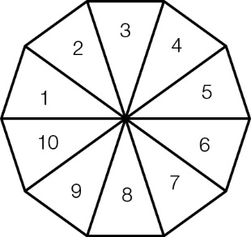

(a) What is the probability of not getting a 3 or a 5?

(b) What is the complement of getting a number less than 3?

Question 17 3 marks [9.6]

The letters of the word MATHEMATICS are written on individual cards. A card is chosen at random. Find the probability that:

(a) the letter ‘M’ is selected

(b) the letter selected is a consonant

(c) the letter selected is one of the letters in the word TEAM.

Question 18 4 marks [9.6]

For a standard pack of 52 playing cards, find the following probabilities:

(a) Pr(Jack or hearts)

(b) Pr(Jack of hearts)

(c) Pr(Jack or hearts but not both)

Question 19 3 marks [9.7]

The Venn diagram shows students who play the piano (P) and play the guitar (G). If one person is chosen at random, find the probability that:

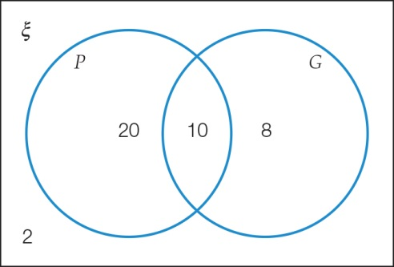

(a) a student plays guitar

(b) a student plays guitar or piano

(c) a student plays both instruments.

Question 20 3 marks [9.7]

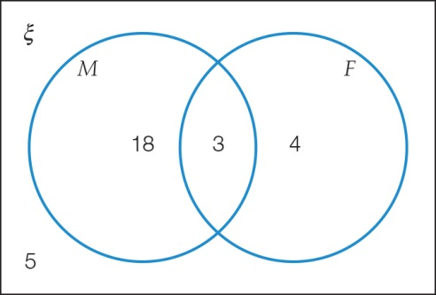

Use the Venn diagram to find:

(a) *n*(ξ)

(b) Pr(*M* or *F*)

(c) Pr(*F*′)

Question 21 4 marks [9.7]

In a group of 30 students, 18 students own a pet fish, 24 students have a pet rabbit and two students have neither a fish nor a rabbit.

(a) Complete the two-way table.

|  |  |  |  |
| --- | --- | --- | --- |
|  | Fish | No fish |  |
| Rabbit |  |  |  |
| No rabbit |  |  |  |
|  |  |  | 30 |

(b) Find the probability that a student chosen at random has a fish and a rabbit.

Short answer results: ___ / 48

Extended answer section

Question 22 9 marks [9.3, 9.4, 9.5]

The following frequency distribution table is incomplete.

(a) Fill in the missing information.

|  |  |  |  |
| --- | --- | --- | --- |
| Class interval | *x* | Frequency (*f*) | *xf* |
| 25–<30 | 27.5 | 7 |  |
| 30–<35 |  | 9 |  |
| 35–<40 |  | 11 |  |
| 40–<45 |  | 14 |  |
| 45–<50 |  | 16 |  |
| 50–<55 |  | 19 |  |
| 55–<60 |  | 14 |  |
|  |  | Σ*f* = | Σ*xf* = |

(b) If a histogram was drawn from the table, what values would be along the horizontal axis?

(c) Find:

(i) the estimated mean

(ii) the modal class interval

(iii) the median class interval.

(d) If a data value was selected at random, what is the probability it is less than 45?

Question 23 10 marks [9.1]

*The big book of numbers* has a section that is 161 words long. Six sets of 10 words were randomly selected from this section:

Set A: of, than, emergence, dimensional, help, showed, In, garden, of, are

Set B: The, string, dimensions, along, of, are, time, but, that, the

Set C: be, Most, dimensional, called, of, them, He, Most, and, of

Set D: to, away, the, see, line, of, version, and, very, our

Set E: that, other, in, people, see, the, an, as, dimension, up

Set F: be, long, and, the, He, hose, than, a, way, example

(a) For each set, find:

(i) the mean number of letters per word

(ii) the proportion of words that contain the letter ‘i’.

(b) Pair the sets (A with B etc) to make three sets of 20 words and repeat the process from part (a).

(c) Describe what happened to the variation in the values of the sample means and sample proportions when the sample size increased.

Question 24 4 marks [9.6, 9.7]

A restaurant offers four entrees (soup, potatoes, squid, and dumplings) and five main courses (beef, chicken, duck, vegetables, and prawns).

(a) List all the possible different meal combinations.

(b) A customer cannot eat prawns or squid. If a dish is selected at random, what is the probability that the customer will get a meal they can eat?

Question 25 5 marks [9.7]

The Venn diagram represents the number of teenagers who participate every week in one or more sports. *A*, *B* and *C* each represent a different sport. Find the following probabilities:

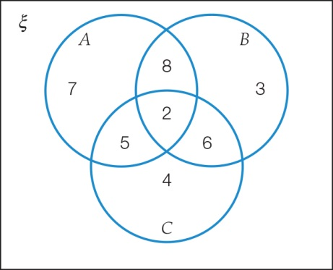

(a) Pr(*A* or *C*)

(b) Pr(*A* and *C*)

(c) Pr(*A* or *B* or *C*)

(d) Pr(*B*‘)

(e) Pr(*A* or *C* but not both)

Extended answer results: ___ / 28

TOTAL test results: ___ / 84